> Non-Linear Algorithms

2. K-Nearest Neighbors (KNN) – Detailed Notes

USE → Iris dataset for model predict
https://scikit-learn.org/1.5/auto_examples/datasets/plot_iris_dataset.html
https://scikit-learn.org/stable/api/sklearn.datasets.html

1. What is K-NN?
- Definition:
K-Nearest Neighbors (KNN) is a supervised learning algorithm used for both classification and regression problems.
It works by finding the K nearest data points to a new data point and making predictions based on their majority vote (classification) or average value (regression).
- Key Idea:
"Similar data points are likely to have similar outcomes."
- Type:
  - Lazy learning: No model is built during training; all computation happens during prediction.
  - Instance-based learning: Stores training data and uses it directly.
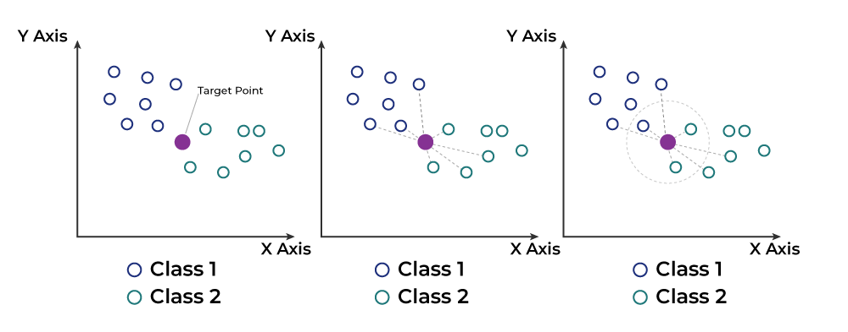

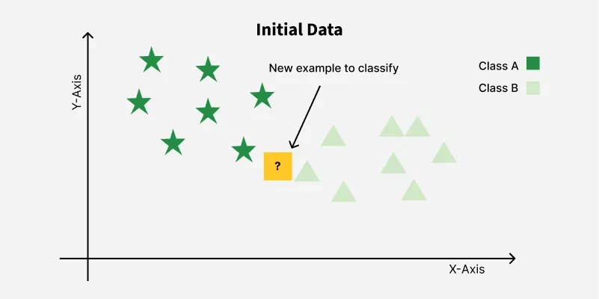

2. KNN Algorithm
Steps:
- Store all the training data.
- Choose the number of neighbors K.
- Calculate the distance (e.g., Euclidean) between the new point and all training points.
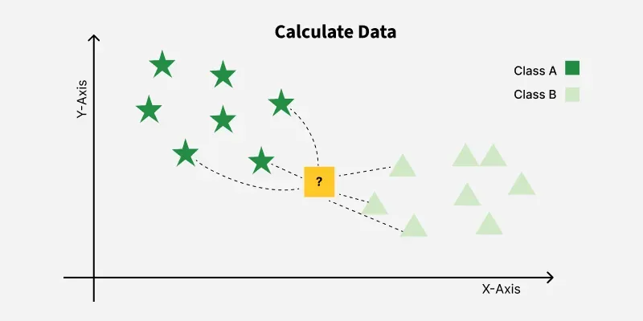
- Sort the distances and select the K nearest neighbors.
- Vote / Average:
  - Classification: Pick the class with the highest frequency among neighbors.
  - Regression: Take the average of neighbors' target values.
- Return the predicted class/value.
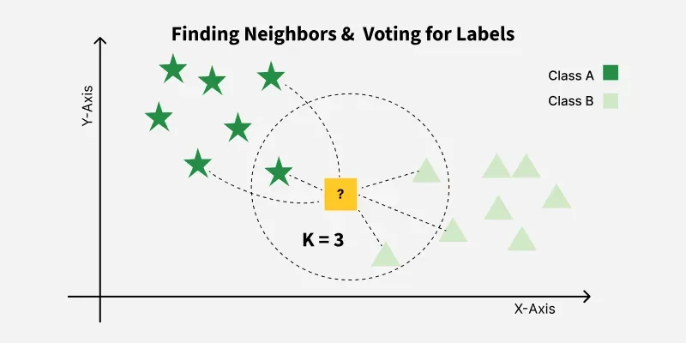

3. Working of KNN – Example
Dataset Example (Fruit classification):
Color | Size | Fruit Type
Red | 5 | Apple
Green | 6 | Pear
Red | 6 | Apple
Yellow | 4 | Banana
If we have a new fruit:
- Color = Red, Size = 5.5
- KNN will:
  - Calculate distances to all fruits in dataset.
  - Pick nearest K neighbors.
  - See which fruit type is most common among neighbors.
  - Predict that type.

4. How to Choose the Value of K?
- Small K (e.g., K=1, K=3):
  - Very sensitive to noise.
  - May overfit.
- Large K (e.g., K=20):
  - More stable predictions.
  - May underfit.
- Best practice:
  - Use Cross-Validation to choose K.
  - Often odd K is chosen for classification to avoid ties.
- Rule of Thumb:
K≈Number of SamplesK \approx \sqrt{\text{Number of Samples}}

5. Advantages
✅ Simple to implement and understand
✅ Works for classification and regression
✅ No training phase (fast training)

6. Disadvantages
❌ Slow prediction for large datasets (must calculate distance for all points)
❌ Sensitive to irrelevant features and different scales (needs feature scaling)
❌ Curse of dimensionality – performance drops with too many features

7. Distance Metrics Used in KNN
- Euclidean Distance:
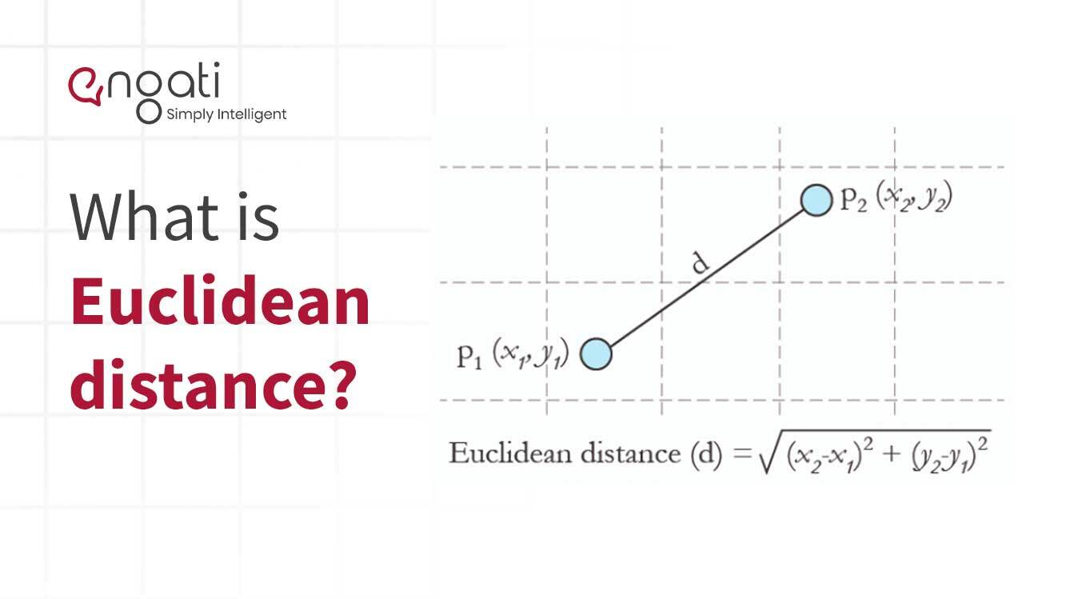
- Manhattan Distance:
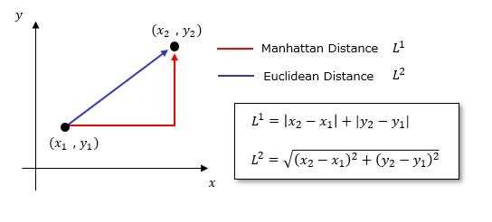
- Minkowski Distance (generalized form)
Minkowski distance is a generalized distance metric used in multi-dimensional space, named after Hermann Minkowski, that encompasses other common distance measures like Euclidean distance and Manhattan distance through a parameter 'p'.
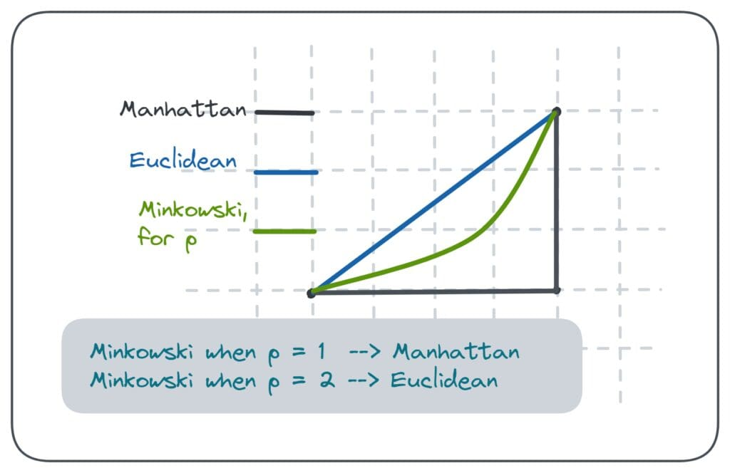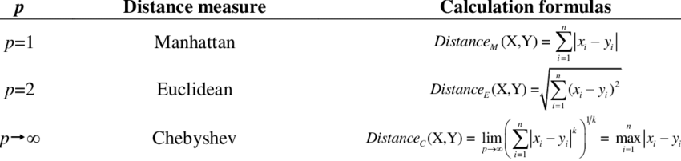
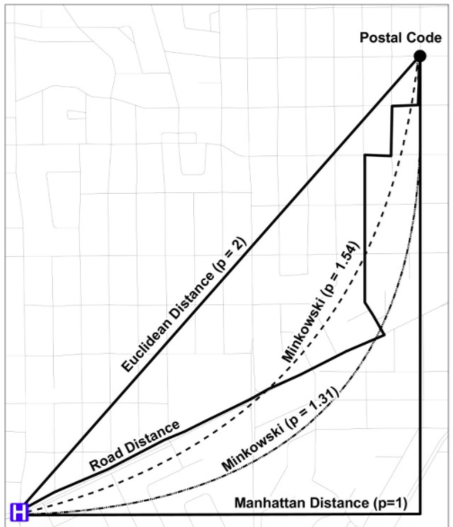
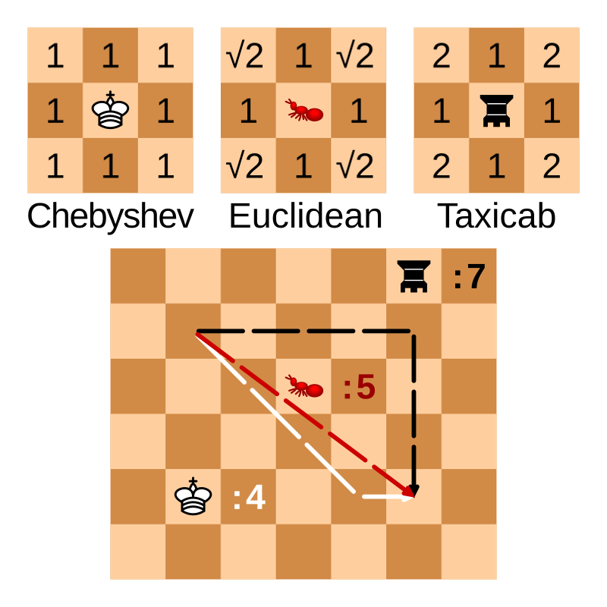
https://tuhinmukherjee74.medium.com/different-types-of-distances-used-in-machine-learning-explained-550e2979752c

8. Assignment
Dataset: Use the Iris dataset from sklearn.
Task:
- Implement KNN for classification to predict flower species.
- Experiment with different K values (1, 3, 5, 7, 11).
- Compare accuracy for each K.
- Plot accuracy vs. K graph.

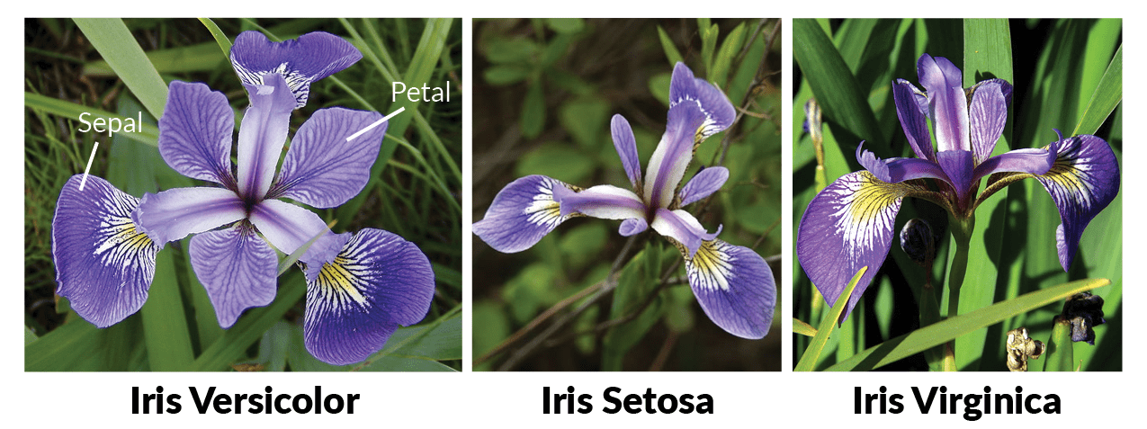

9. Python Code Example
from sklearn.datasets import load_iris
from sklearn.model_selection import train_test_split
from sklearn.neighbors import KNeighborsClassifier
from sklearn.metrics import accuracy_score
import matplotlib.pyplot as plt

# Load dataset
iris = load_iris()
X, y = iris.data, iris.target

# Train-Test Split
X_train, X_test, y_train, y_test = train_test_split(X, y, test_size=0.2, random_state=42)

# Try different values of K
k_values = [1, 3, 5, 7, 9, 11]
accuracies = []

for k in k_values:
model = KNeighborsClassifier(n_neighbors=k)
model.fit(X_train, y_train)
y_pred = model.predict(X_test)
acc = accuracy_score(y_test, y_pred)
accuracies.append(acc)
print(f"K={k}, Accuracy={acc:.4f}")

# Plot accuracy vs K
plt.plot(k_values, accuracies, marker='o')
plt.xlabel('K Value')
plt.ylabel('Accuracy')
plt.title('KNN Accuracy vs K')
plt.show()

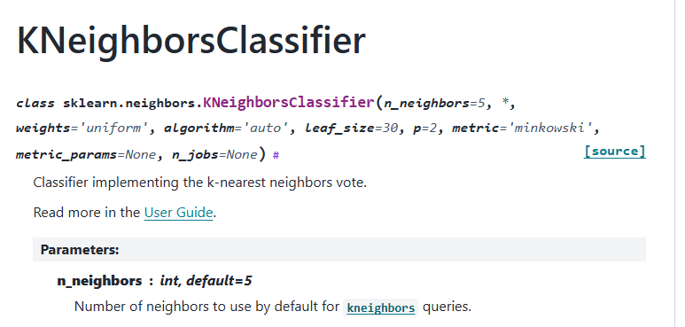

—-------------------------
—

6. Use Cases
- Recommender systems (finding similar items/users).
- Handwriting recognition (digit classification).
- Medical diagnosis (classifying patient conditions).
- Fraud detection.

7. Assignment
Dataset: Iris.csv or any classification dataset.
Tasks:
- Implement KNN from scratch (without scikit-learn).
- Compare with KNeighborsClassifier from scikit-learn.
- Find best K using cross-validation.
- Plot accuracy vs K.

💻 Streamlit App: KNN Interactive Tool
import streamlit as st
import pandas as pd
import numpy as np
from sklearn.model_selection import train_test_split
from sklearn.preprocessing import StandardScaler
from sklearn.neighbors import KNeighborsClassifier
from sklearn.metrics import accuracy_score, confusion_matrix, classification_report
import matplotlib.pyplot as plt
import seaborn as sns

st.title("🔍 K-Nearest Neighbors (KNN) Classifier App")

# File upload
uploaded_file = st.file_uploader("Upload CSV file", type=["csv"])
if uploaded_file is not None:
df = pd.read_csv(uploaded_file)
st.subheader("📊 Dataset Preview")
st.write(df.head())

# Feature & target selection
all_columns = df.columns.tolist()
target_col = st.selectbox("Select Target Column", all_columns)
feature_cols = st.multiselect("Select Feature Columns", [col for col in all_columns if col != target_col])

if feature_cols and target_col:
X = df[feature_cols]
y = df[target_col]

# Train-test split
test_size = st.slider("Test Size (fraction)", 0.1, 0.5, 0.2)
random_state = st.number_input("Random State", value=42, step=1)

X_train, X_test, y_train, y_test = train_test_split(X, y, test_size=test_size, random_state=random_state)

# Scaling
scaler = StandardScaler()
X_train_scaled = scaler.fit_transform(X_train)
X_test_scaled = scaler.transform(X_test)

# K selection
k_value = st.slider("Select K", 1, 20, 5)

# Model training
knn = KNeighborsClassifier(n_neighbors=k_value)
knn.fit(X_train_scaled, y_train)
y_pred = knn.predict(X_test_scaled)

# Metrics
acc = accuracy_score(y_test, y_pred)
st.subheader(f"✅ Accuracy: {acc:.2f}")

st.text("Classification Report")
st.text(classification_report(y_test, y_pred))

# Confusion Matrix
cm = confusion_matrix(y_test, y_pred)
fig, ax = plt.subplots()
sns.heatmap(cm, annot=True, fmt='d', cmap='Blues', ax=ax)
ax.set_xlabel("Predicted")
ax.set_ylabel("Actual")
st.pyplot(fig)

✅ How this helps you in class:
- Theory + Hands-on in one session.
- Students can upload any dataset and experiment.
- They will understand how K affects predictions in real-time.
- Encourages interactive learning.
If you want, I can extend this app to also include:
- Decision boundary plots (for 2D datasets)
- Regression version of KNN
- Auto K tuning using cross-validation.
Do you want me to add these advanced features too? That would make it a complete KNN learning tool.
K-Nearest Neighbor(KNN) Algorithm - GeeksforGeeks

KD-TREE AND BALL TREE IN KNN ALGORITHM | by Narasimharaodevisetti | Medium
